**What are NFTs (non-fungible tokens)?**

NFTs belong to the crypto category of “tokens”* - non-fungible means “not exchangeable” in German.

If you compare Bitcoin, it doesn't matter which bitcoin you own - all coins are the same and interchangeable. This is different with NFTs.

Each NFT is unique and has a different value - no two NFTs are the same.

NFTs have only been in the public eye for 1-2 years, although the first NFTs came onto the market with the Cryptopunks in 2017.



**What are NFTs used for?**

NFTs have different areas of application. They are often referred to as art when used. But they are more.

So they can be used as an entry ticket for conferences, as a member card for a club or insurance policies and rental contracts can be displayed there.

NFTs are currently also very popular in the gaming sector, and virtual land is already being sold in the real estate sector.

E.g. ticket/admission ticket for a conference:

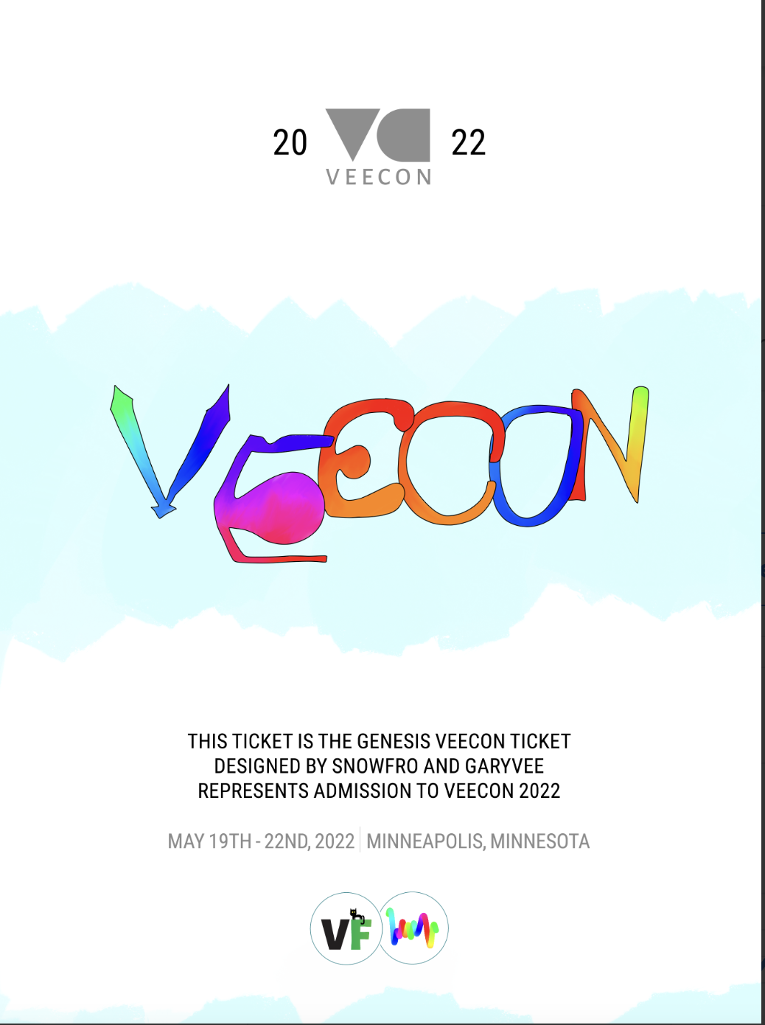

E.g. Member Cards:

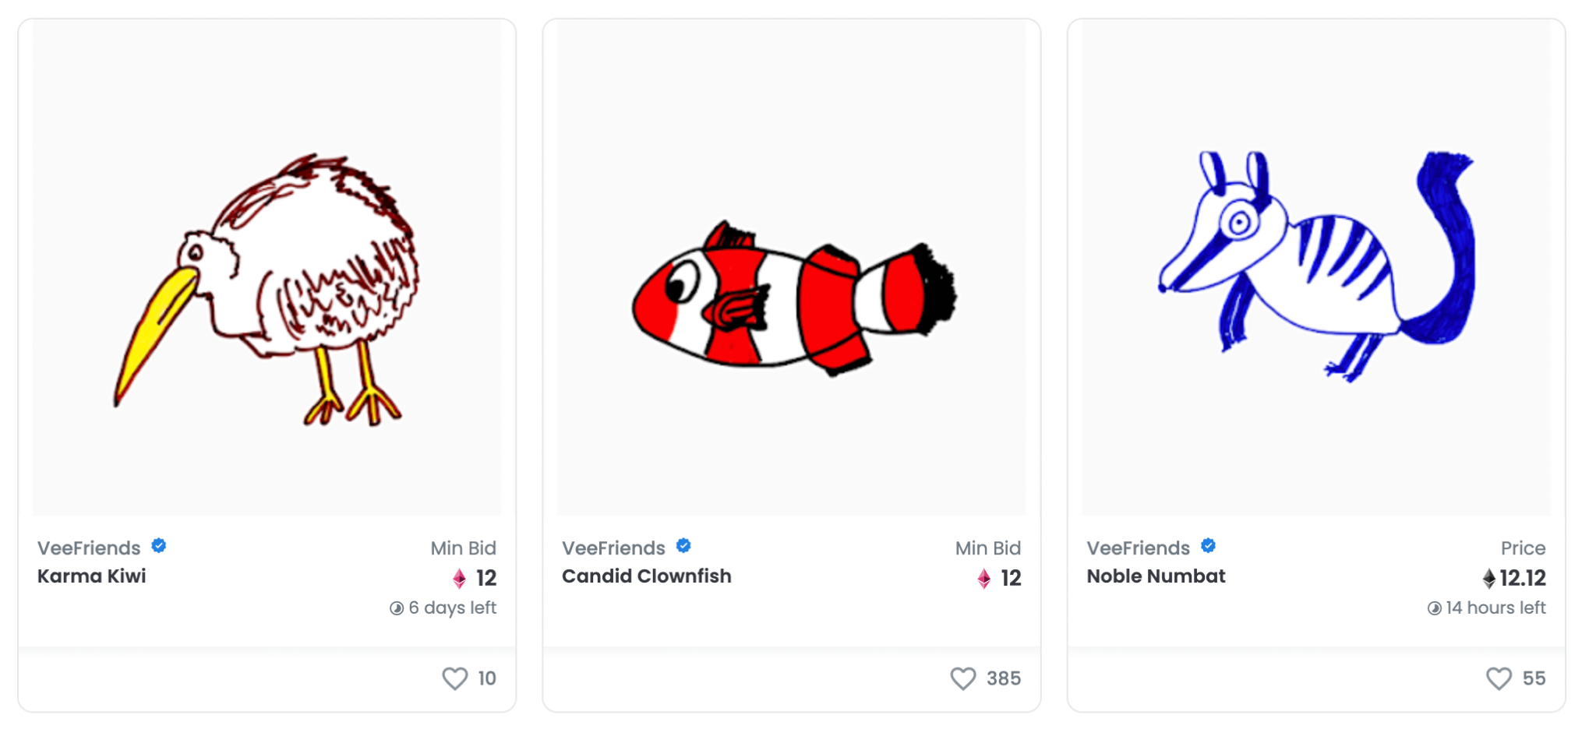

As you can see, NFTs are more than just art and have a multitude of possible applications that we encounter in everyday life.

*see video “What are Tokens” - Crypto Basics